**Open Tag3 Manual**

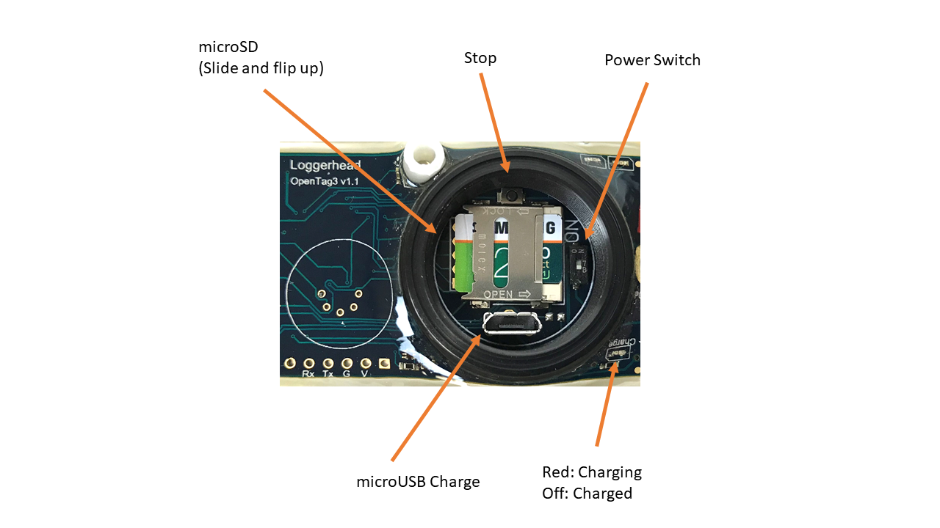

**Overview**

OpenTag3 recordsmotion sensors at 50 Hz, and depth, temperature, light, and speed sensors at 1 Hz to CSV files. Files are 1 hour long by default. There will be a short gap between files. OpenTag3 supports 32 GB or smaller microSD cards.

OpenTag3 is open source. Software is located at https://github.com/loggerhead-instruments/OpenTag3

* Accelerometer, Gyroscope, Magnetometer (MPU9250): 100 Hz
* Pressure/Temperature (MS5837 or Keller PA7LD): 1 Hz
* RGB light level (ISL29125): 1 Hz
* Burn wire release: controls a FET switch to ground which can be used to corrode a stainless steel wire in seawater

**Quick Start**

**1. Setting Time**

The time is set by saving the setup.txt card with a date and time, ejecting the card from the computer, and inserting the card into the OpenTag board. When the time stored on the card occurs, the power switch should be turned on to set the time on the clock.

Once the time is set, as long as there is charge left on the battery, the current time will be retained (even with the power dip switch off).

**2. Starting Record**

Insert the microSD card in the recorder. The card holder is flip top: slide and flip up.

To start recording, slide the dip switch to the ON position. The recorder will set the time if present in the setup.txt file and start recording.

Lightly grease the o-ring and screw the lid down tightly. It should be slightly more than finger tight.

**3. Stopping Record**

Press the Stop button located inside the ring. After the red LED turns on solid red, turn off the power switch. If the DIP switch is not turned off in 30 seconds, recording will resume.

**OpenTag3 LED Startup Sequence**

|  |  |  |
| --- | --- | --- |
| **Red LED** | **Green LED** | **Description** |
| Solid On | Flashing | Green LED flashes for current hour (e.g. at 09:40 it will flash 9 times). Used so you know time is set approximately correctly. |
| Off | Solid On | Sensor initialization. Camera should power on with red LED underneath on DVR illuminated (you can see from side of tag) |
| Flashing | Flashing | Flash simultaneously 11 times, to give camera time to boot. |
| Off | Blink once per second | Recording |

**OpenTag3 Error Codes at Startup**

Error codes are indicated by a flashing red LED.

|  |  |
| --- | --- |
| **Flash Rate (flashes per second)** | **Error** |
| 3 | Error initializing microSD card |
| 10 | Low voltage (<3.5V) |
| 5 | Real-time clock failed to tick |
| 2.5 | Pressure sensor or light sensor failed to initialize |
| 1.6 | IMU sensor failed to initialize |
| Rapid flashing for 15s | Pressure sensor out of spec, but tag will continue to record |
|  |  |

**Example setup.txt File (**set time to 10 April 2018 at 1 PM; Trigger burn after 400 minutes)

// Set Time

TM 18-04-10 13:00:00

// Set burn in x minutes

BM 400

**setup.txt Commands**

setup.txt should be saved in root of microSD (not in a directory)

// Indicate lines that are comments. Any line with // will be ignored

|  |  |  |
| --- | --- | --- |
| **Command** | **Function** | **Example** |
| TM | Sets time (YY-MM-DD hh:mm:ss) | TM 18-04-10 13:00:00 |
| BM | Burn in mmm minutes from start | BM 60(burn 60 minutes after power on) |
| LD | Disable blinking green LED | LD |
| HE | Enable Hall Sensor to Trigger Red LED (for testing) | HE |

**Charging**

The lithium battery can be charged by connecting a microUSB cable to the OpenTag3 and a PC or other charger.

When charging the red LED will be on. When charging is complete the LED will turn off. Charging will typically take less than 10 hours.

**Power**

Tags can be supplied with either 1 or 2 lithium polymer rechargeable batteries (2500 mAh).

Run time with 1 battery is approximately 7 days.

Run time with 2 batteries is approximately 14 days.

**Burn Wire**

A burn wire is a corrodible stainless steel wire that can be used to release the AMX from a platform or release suction from suction cups. The recommended wire is from McMaster-Carr (302/304 stainless steel wire 0.01” diameter). [https://www.mcmaster.com/ - 6517k61/=17yvpwx](https://www.mcmaster.com/#6517k61/=17yvpwx)

The timing of the burn wire start is controlled by the BM command in the setup.txt file.

1. Run wire through one of the holes in the mounting plate, and start screw in side. Wrap excess wire around screw.

|  |  |
| --- | --- |
|  |  |

1. Attach mount plate to tag and wrap wire around center post. Screw down acorn nut to hold wire in place.

|  |  |
| --- | --- |
|  |  |

1. Run wire through opposite side of plate and insert screw to tighten down. Wrap around screw a few turns. The burn wire should be taut to help it break when it starts to corrode. Cut off excess wire.

**VHF**

If your AMX has the optional VHF, it will turn on based on the depth or the status of the burn wire. If the depth is deeper than 1.0 m, the VHF will turn off. The VHF will be turned on and stay on after the burn wire is triggered.

**Depth Sensors and Maximum Depth**

The OpenTag3 is equipped with one of two types of pressure sensors, each of which has a maximum depth that it can sustain. If the tag could go deeper than 300 m, the air void where the microSD card is located should be filled with mineral oil. Mineral oil is non-conductive, and will keep the cap from imploding if the tag goes deeper than 300 m.

**TE Connectivity**

30 Bar (300 m max depth)

**Keller**

200 Bar (2000 m max depth)

Or other sensor as specified.

**Sensor Calibration**

All sensors used on OpenTag are digital, in that they have their own analog-to-digital converter. The values stored by OpenTag are calibrated using the calibration values supplied in the technical specification sheets.

Example data file:

|  |  |  |  |  |  |  |  |  |  |  |  |  |  |  |  |  |  |  |  |  |  |  |  |  |  |  |  |  |  |  |  |  |  |  |  |  |  |  |  |  |  |  |  |  |  |  |  |  |  |  |  |  |  |  |  |  |  |  |  |  |  |  |  |  |  |  |  |  |  |  |  |  |  |  |  |  |  |  |  |  |  |  |  |  |  |  |  |  |  |  |  |  |  |  |  |  |  |  |  |  |  |  |  |  |  |  |  |  |  |  |  |  |  |  |  |  |  |  |  |  |  |  |  |  |  |  |  |  |  |  |  |  |  |  |  |  |  |  |  |  |  |  |  |  |  |  |  |  |  |  |  |  |  |  |  |  |  |  |  |  |  |
| --- | --- | --- | --- | --- | --- | --- | --- | --- | --- | --- | --- | --- | --- | --- | --- | --- | --- | --- | --- | --- | --- | --- | --- | --- | --- | --- | --- | --- | --- | --- | --- | --- | --- | --- | --- | --- | --- | --- | --- | --- | --- | --- | --- | --- | --- | --- | --- | --- | --- | --- | --- | --- | --- | --- | --- | --- | --- | --- | --- | --- | --- | --- | --- | --- | --- | --- | --- | --- | --- | --- | --- | --- | --- | --- | --- | --- | --- | --- | --- | --- | --- | --- | --- | --- | --- | --- | --- | --- | --- | --- | --- | --- | --- | --- | --- | --- | --- | --- | --- | --- | --- | --- | --- | --- | --- | --- | --- | --- | --- | --- | --- | --- | --- | --- | --- | --- | --- | --- | --- | --- | --- | --- | --- | --- | --- | --- | --- | --- | --- | --- | --- | --- | --- | --- | --- | --- | --- | --- | --- | --- | --- | --- | --- | --- | --- | --- | --- | --- | --- | --- | --- | --- | --- | --- | --- | --- | --- | --- | --- | --- | --- |
|  | |  |  |  |  |  |  |  |  |  |  |  |  |  |  |  |  |  |  | | --- | --- | --- | --- | --- | --- | --- | --- | --- | --- | --- | --- | --- | --- | --- | --- | --- | --- | | accelX | accelY | accelZ | magX | magY | magZ | gyroX | gyroY | gyroZ | date | red | green | blue | mBar | depth | temperature | spin | V | | 42 | 105 | -2014 | 226 | -202 | -246 | 54 | 44 | 0 |  |  |  |  |  |  |  |  |  | | 46 | 105 | -2008 | 231 | -203 | -247 | 51 | 41 | -2 |  |  |  |  |  |  |  |  |  | | 44 | 107 | -2016 | 230 | -204 | -238 | 52 | 43 | 0 |  |  |  |  |  |  |  |  |  | | 48 | 107 | -2007 | 231 | -207 | -249 | 50 | 44 | 0 |  |  |  |  |  |  |  |  |  | | 41 | 107 | -2012 | 227 | -207 | -245 | 53 | 44 | -1 |  |  |  |  |  |  |  |  |  | | 43 | 109 | -2004 | 227 | -211 | -239 | 52 | 43 | -2 |  |  |  |  |  |  |  |  |  | | 42 | 109 | -2006 | 235 | -205 | -249 | 52 | 45 | 0 | 18-04-22T010:28:17Z | 1476 | 1539 | 839 | 1008.41 | -0.01 | 24.53 | 0 | 3.69 | |  |  |  |  |  |  |  |  |  |  |  |  |  |  |  |  |
|  |  |  |  |  |  |  |  |  |  |  |  |  |  |  |  |  |  |
|  |  |  |  |  |  |  |  |  |  |  |  |  |  |  |  |  |  |
|  |  |  |  |  |  |  |  |  |  |  |  |  |  |  |  |  |  |
|  |  |  |  |  |  |  |  |  |  |  |  |  |  |  |  |  |  |

|  |  |  |  |  |  |  |  |  |  |  |  |  |  |  |  |  |  |  |  |  |  |  |  |  |  |  |  |  |  |  |  |  |  |  |  |  |  |  |  |  |  |  |  |  |  |  |  |  |  |  |  |  |  |  |  |  |  |  |  |  |
| --- | --- | --- | --- | --- | --- | --- | --- | --- | --- | --- | --- | --- | --- | --- | --- | --- | --- | --- | --- | --- | --- | --- | --- | --- | --- | --- | --- | --- | --- | --- | --- | --- | --- | --- | --- | --- | --- | --- | --- | --- | --- | --- | --- | --- | --- | --- | --- | --- | --- | --- | --- | --- | --- | --- | --- | --- | --- | --- | --- | --- |
|  | **Sensor Calculations**  The IMU data (accelerometer, magnetometer, and gyroscope) and RGB light sensor data are stored as 16-bit integers. They need to be multiplied by a calibration factor to get appropriate units.  The pressure data are stored as mBar and a depth calculation is performed assuming saltwater (111.377 mBar/m) and a surface pressure of 1010.0 mBar.  The temperature data are stored as degrees Celsius.  Spin is the number of rotations of the impeller per second.  V is battery voltage.  Date is the date and time from the real-time clock and assumes the time was set to UTC.  Sensor Calibration Factors: Multiply the sensor values by these values   |  |  |  | | --- | --- | --- | | **Sensor** | **Calibration Factor** | **Units** | | Accelerometer | 16 g / 32768 = 0.00048828 | g | | Magnetometer | 4800 uT / 32768 = 0.146484375 | microTesla | | Gyroscope | 1000 deg/s / 32768 = 0.0030517578 | Degrees / second | | Red | 20 uW/cm2 / 65536 = 0.003051758 | microWatt/cm2 | | Green | 18 uW/cm2 / 65536 = 0.000274658 | microWatt/cm2 | | Blue | 30 uW/cm2 / 65536 = 0.000457764 | microWatt/cm2 | | | | | | | | | | | | | |  |  | |  | |  |  | |  |  |  |  | |  | |  |  | |  | |  | |  | |  | |
|  |  | | | | | | | | | | | | |  |  | |  | |  |  | |  |  |  |  | |  | |  |  | |  | |  | |  | |  | |
|  |  |  |  |  |  |  |  |  |  |  |  |  |  | | |  | |  | | |
|  |  |  |  |  |  |  |  |  |  |  |  |  |  | | |  | |  | | |
|  |  | | | | | | | | | | | | |  |  | |  | |  |  | |  |  |  | |  | |  | | |  |  |  | |  | |  | |  |
|  |  | | | | | | | | | | | | |  |  | |  | |  |  | |  |  |  | |  | |  | | |  |  |  | |  | |  | |  |
|  |  | | | | | | | | | | | | |  |  | |  | |  |  | |  |  |  | |  | |  | | |  |  |  | |  | |  | |  |

**Making a Recording for Gyroscope Calibration**

Note that when the tag is recording without moving, the gyroscope should have values of 0 degrees/second, but there is typically an offset.

Place device in a known orientation for a few seconds when recording starts. Generally a flat surface is a good idea.

The values for the gyroscope from this offset calibration recording should be averaged for each axis, and then subtracted from data collection files.

X Gyroscope offset = mean (gyroX)

Y Gyroscope offset = mean (gyroY)

Z Gyroscope offset = mean (gyroZ)

**Making a Recording for Magnetometer Offset Calibration**

The purpose of the magnetometer calibration is to record data from all possible orientations. This is used to correct for offsets in the magnetometer due to nearby metals. For the first recording, rotate the device in all possible orientations (both horizontally and vertically). Put on some LMFAO and do some shufflin'. These data can be used to determine the offset caused by nearby metals in post-processing.

The values for the magnetometer from this offset calibration recording should be analyzed by finding the minimum and maximum values for each axis. Subtract these offsets from the X, Y, and Z magnetometer channels.

X Magnetometer offset = (max(magX) – min(magX)) / 2

Y Magnetometer offset = (max(magY) – min(magY)) / 2

Z Magnetometer offset = (max(magZ) – min(magZ)) / 2

**Revision History**

|  |  |
| --- | --- |
| 23 April 2018 | Initial Manual |
| 31 January 2019 | Added red LED error codes |